Figure 17 from CT course
Tatsugami F, Higaki T, Nakamura Y, Honda Y, Awai K. Dual-energy CT: minimal essentials for radiologists. Jpn J Radiol. 2022;40(6):547-559. doi:10.1007/s11604-021-01233-2
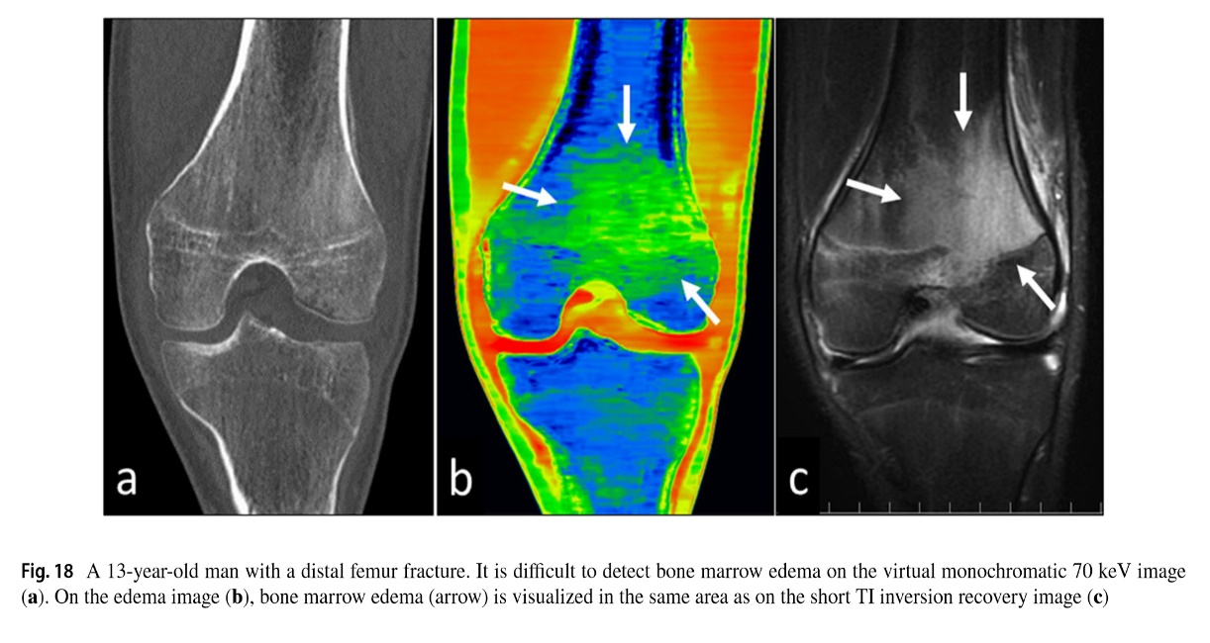
Figure 17: Bone marrow edema visualization with DECT and MRI. 13-year old patient with an undisplaced femur fracture. The bone marrow edema is difficult to see on the virtual monochromatic 70 keV image (a). The color-coded VNCa image (b) shows the bone marrow edema as green (arrows). A STIR MRI image (c) confirms the edema in the same area as on the CT (arrows).10

